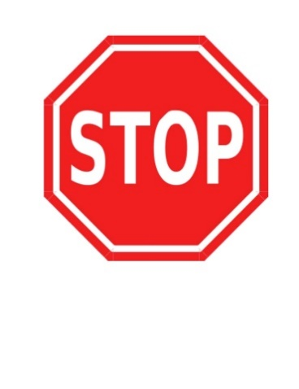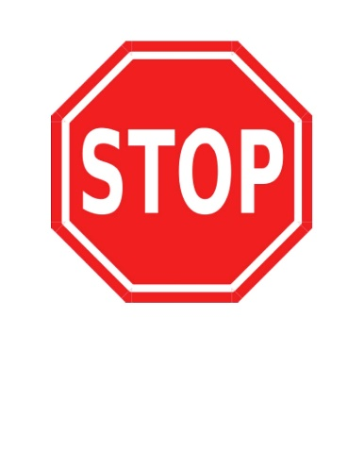**Directions: Cut on the line until you reach the STOP sign.**

Name: ____________________ Date: _________________

